Manufacturing Process

Now, after the discussion and understanding about the process of High Pressure Die Casting in detail,

the following steps are involved in the entire manufacturing process of a die:

- Design
- Casting
- Assembly

After the die is manufactured, for the production of the component, the die is sent to the Production unit, where the component is manufactured and further steps are taken.
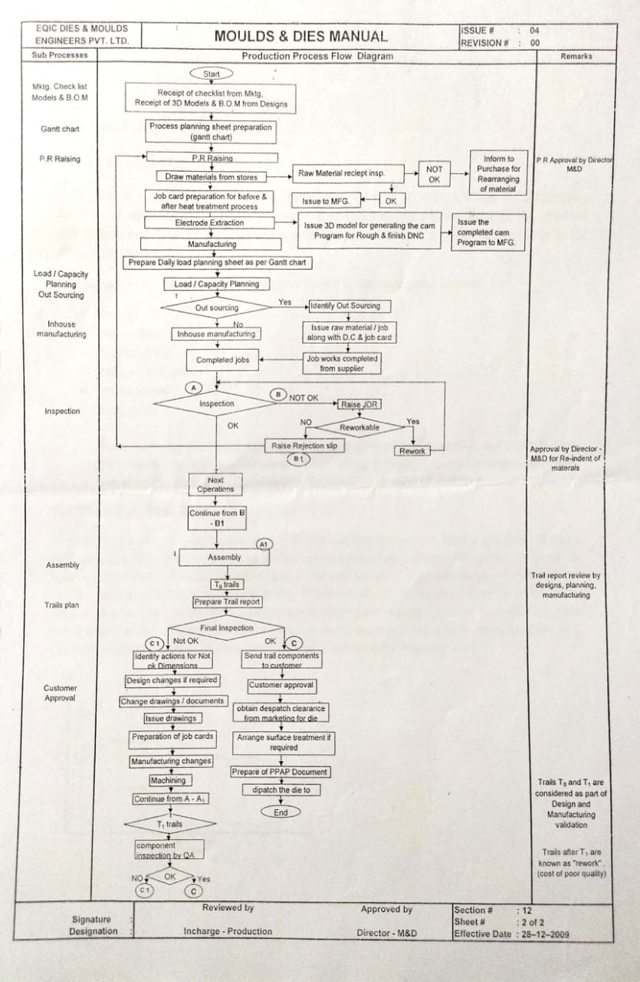
DESIGN
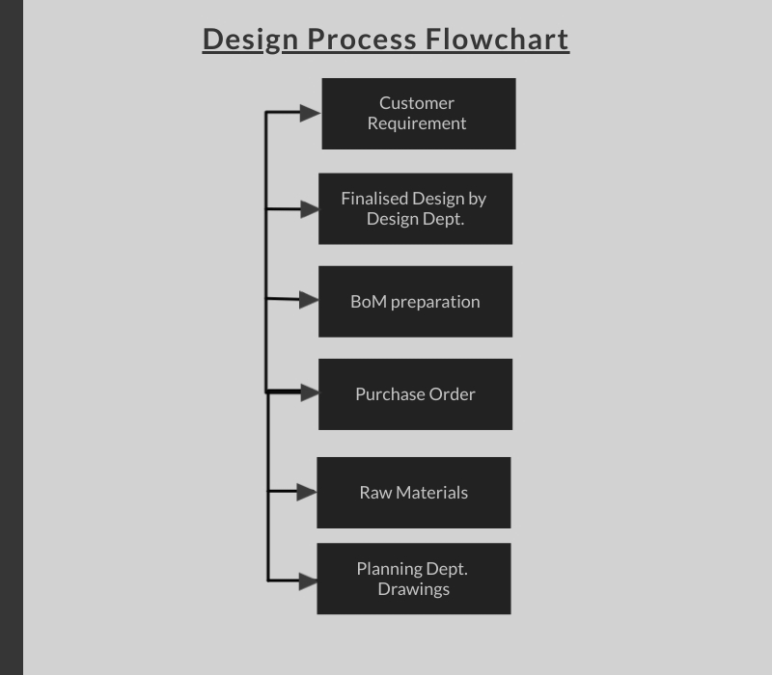

Customer Requirement:

The customer produces the requirement and the necessary designs and drawings of the die for manufacture which is checked by the design dept. for any improvements or changes that need to be done in order to produce a quality product with almost nil defects. If there are any changes in the design as compared to the customer requirement, the same is intimated to the customer for approval and is forwarded to design dept. for finalisation of designs and drawings.

Finalised Design:

Once the design is approved by the customer, the design dept. finalises the designs for manufacturing and further production of the die. For, UNIRAC die, the finalised designs are as follows:

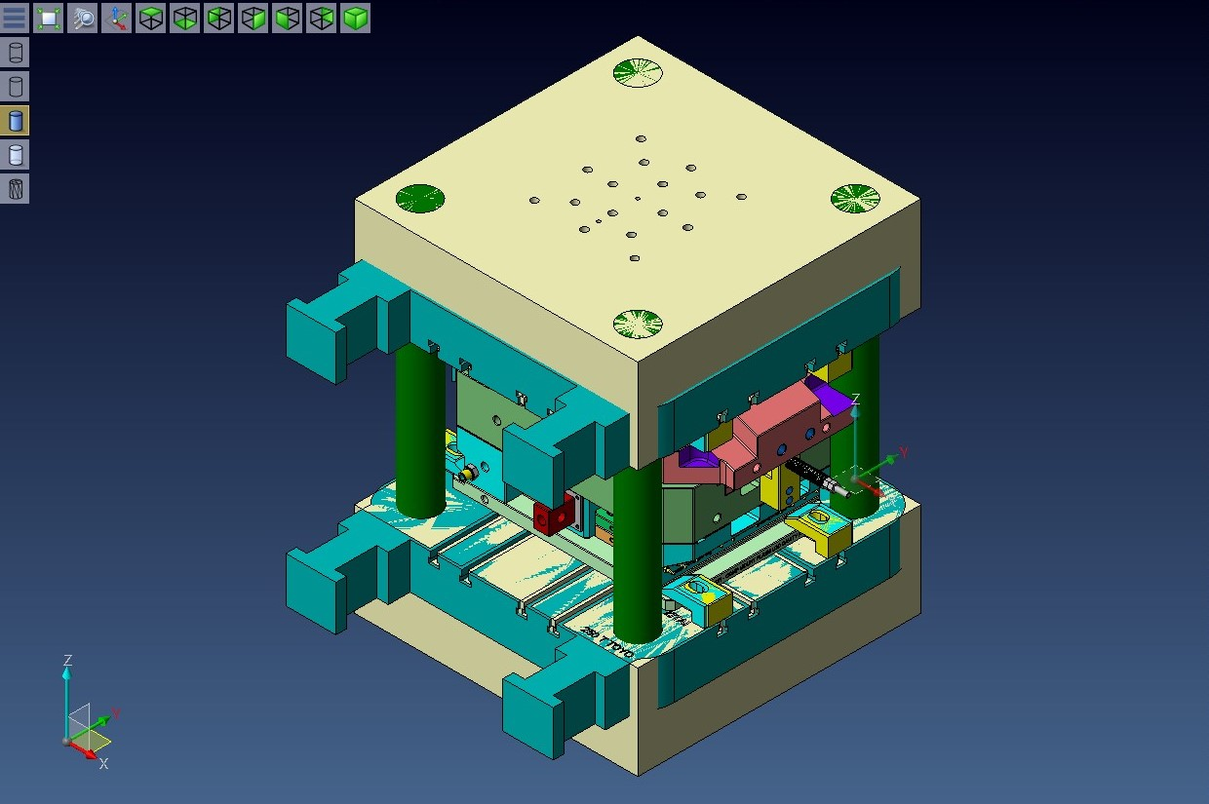

CAVITY HOUSING:

Cavity housing houses the cavity insert which is clamped in the housing with the help of screws.

CORE HOUSING:

The core housing houses the core insert which is clamped with the help of
Screws.

RUNNERS:

Runners are the passages through which molten metal passes into the mould cavity.
.
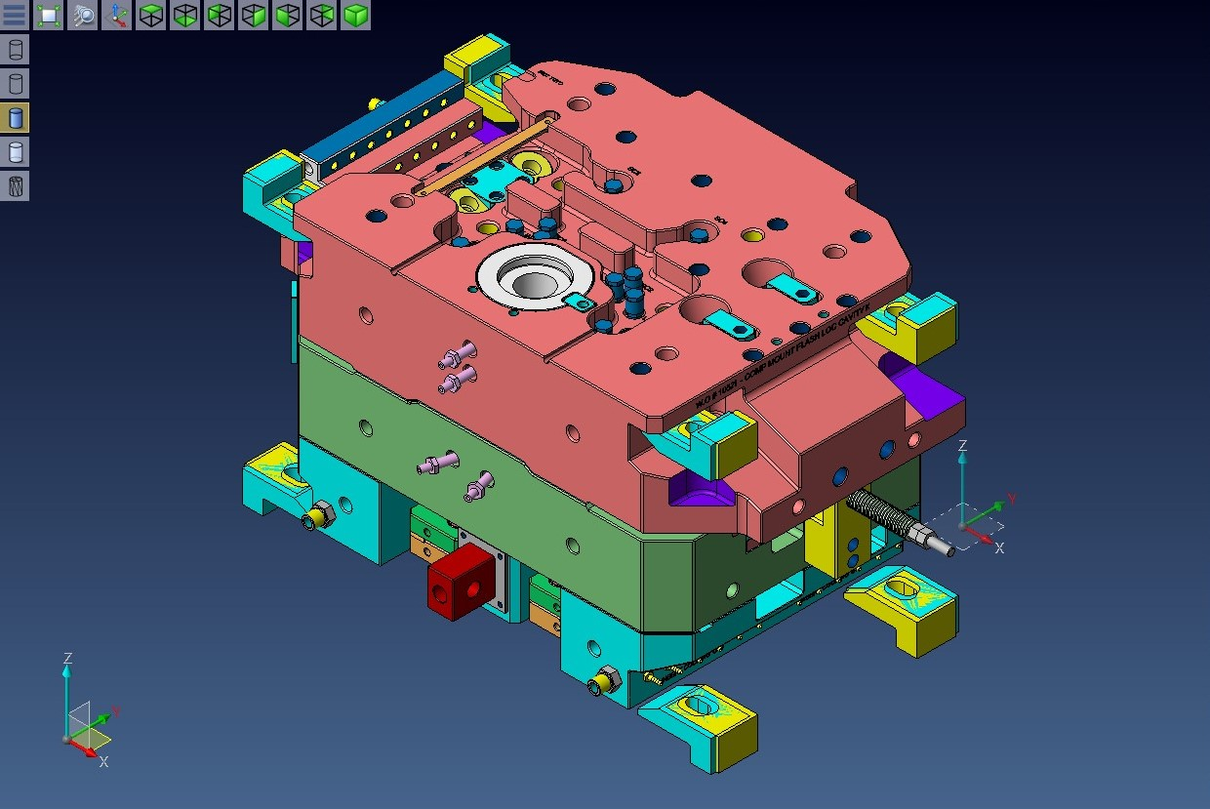

EJECTOR PINS:

The die opens after the solidification of the molten alloy, the solidified casting has to be ejected out and this is done with the help of ejector pins.

EJECTOR BACK PLATE:

It supports the ejector retainer plate for the purpose of retaining the ejector and the housing elements within the ejector retainer plate.

SPREADER AND SPRUE BUSH:

During the casting process the hot molten metal from the furnace is transferred to the shot cylinder. This shot is advanced further to the sprue bush by the plunger. the function of the spreader is to allow the molten metal or help it spread all over the gap between the core and cavity.
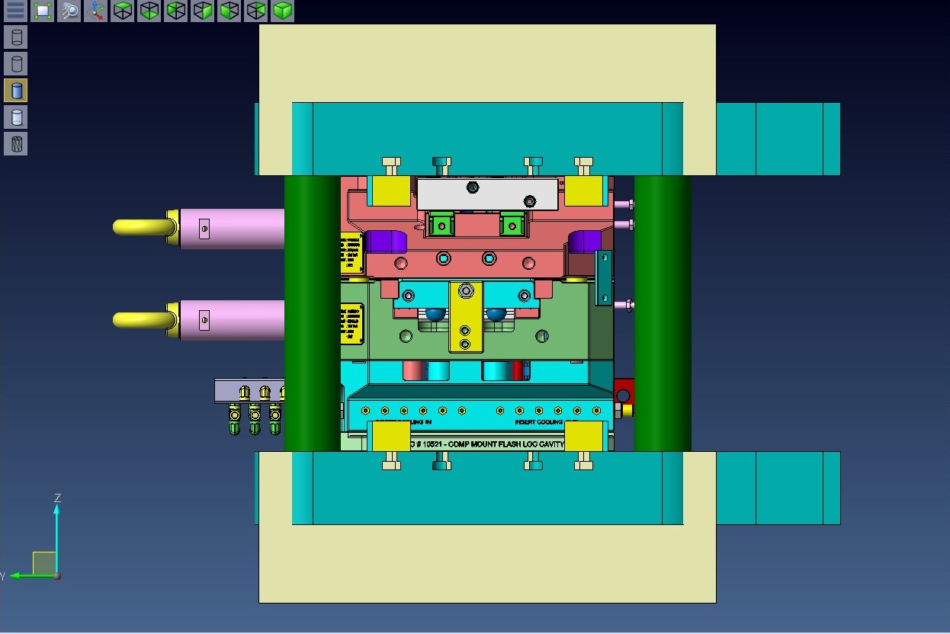

BACK PLATE:

Back plate plate Holds the movable portion of the die assembly and is clamped to the moving plate of the die casting machine.

GUIDE PILLARS AND GUIDE BUSHES :

To form a wall thickness of the casting, it is necessary to ensure that the core and cavity are kept in alignment after every cycle. This work is done by guide pillars and bushes.

OVER FLOWS:

These are the passages through which excess material tries to escape after filling the mould cavity gap.
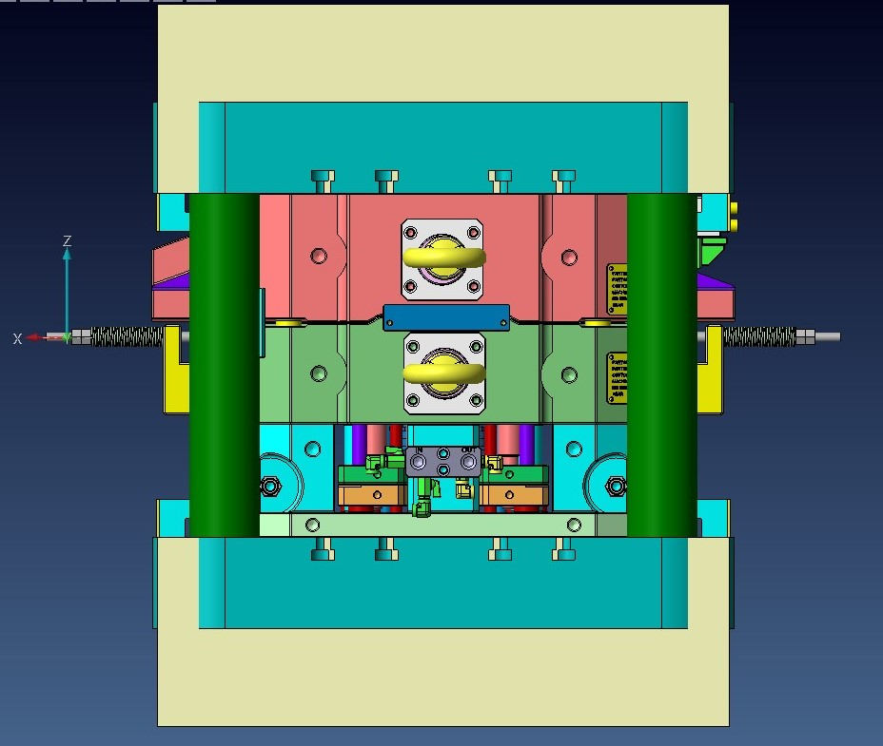

CORE PINS:

Core pins are placed in a mould cavity to shape deep and narrow holes in the part.

EJECTOR GUIDE PILLAR AND EJECTOR GUIDE BUSH:

The ejector assembly needs guiding to move forward such that the casting is ejected out in line. Therefore, the guiding of the ejector assembly is done with the help of ejector guide pillars and bushes. They are placed in the ejector retainer plate and the ejector bush is press
lifted into the core housing from the bottom.

CHILL VENT:

After the excess material passes over the overflows it reaches out to chill vents from where it escapes out.
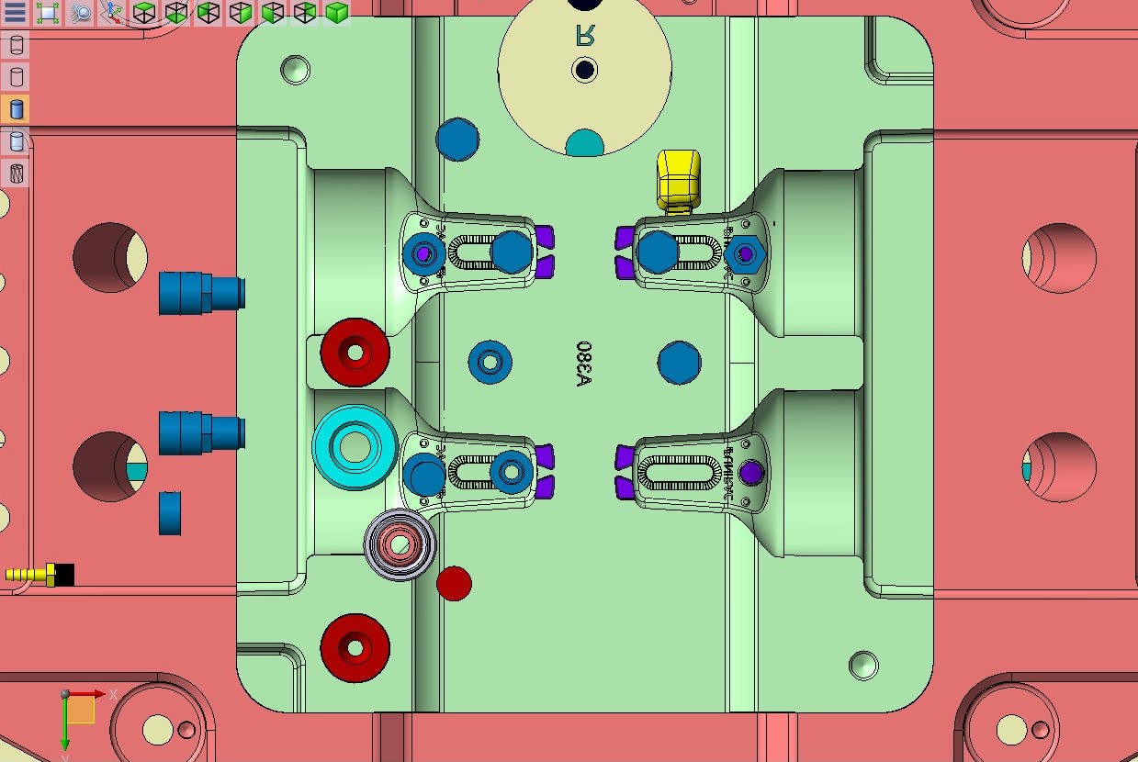

CAVITY INSERT:

A separate die component inserted into the die block to form an external feature of the cavity. Sometimes, the entire cavity block is considered as cavity insert.

CORE:

A part of the die casting that forms an internal feature of the casting and forms a separate from the cavity block.

PLUNGER BUSH:

Plunger bush is placed in a fixed die insert, along with the rod it helps in injecting the molten material into the die.

BoM :
A bill of materials or product structure (sometimes bill of material, BOM or associated list) is a list of the raw materials, sub-assemblies, intermediate assemblies, sub components, parts and the quantities of each needed to manufacture an end product.

A BOM may be used for communication between manufacturing partners, or confined to a single manufacturing plant. A bill of materials is often tied to a production order

BOM is divided into three lists, MB Vap Items BoM, M&D Vap Items BoM, BoM-MD Cooling & L.S & Fasteners & STD Items and Screws BoM:

The first list consists of the major parts of the die which are mostly outsourced jobs in the Bill of Materials.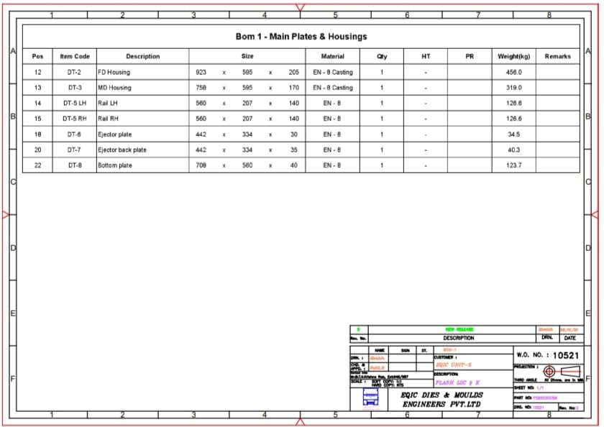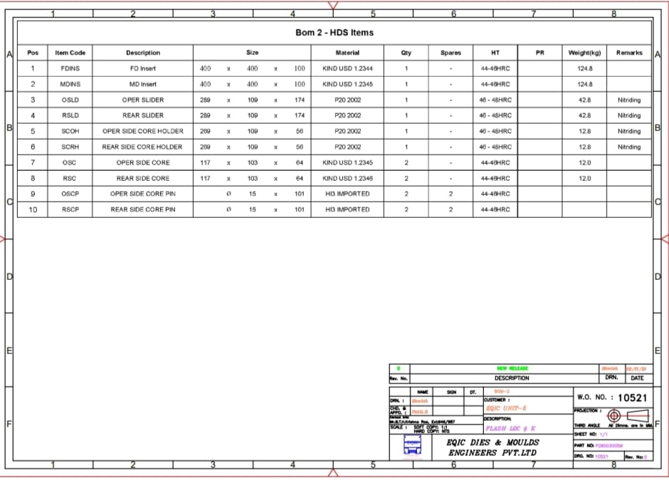 These are the materials used which don't appear after the die is assembled; these help in completion of the core and the cavity insert.

These also play a very important role in the ejection of the component; the core pins help in making holes in the component if there are any in the component and the ejector pins help in the ejection of the component.

Plunger bush is the opening through which the molten material is poured into the cavity and . Spreader helps in the equal distribution of the molten material into the cavity.

The remaining parts like local insert, guides, wedges, side cores, and slider help in the completion of the core and the cavity. Sliders are also fitted with hydraulic pushers which are automated and reduce the manpower and increase the precision in manufacturing of the die.
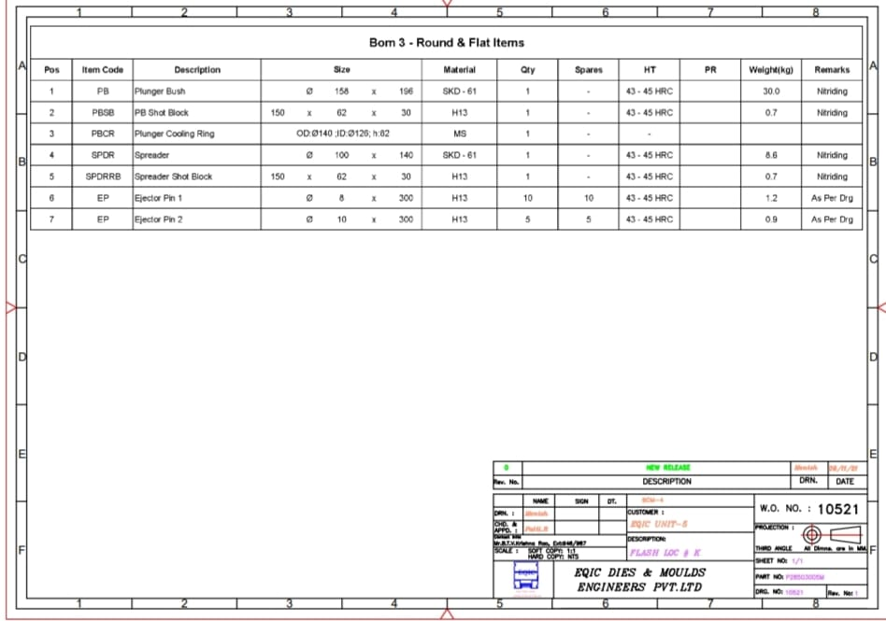

These are the basic parts for assembling the die; these are mostly the outsourced jobs. Die manufacturing comes to a halt in the absence of these parts.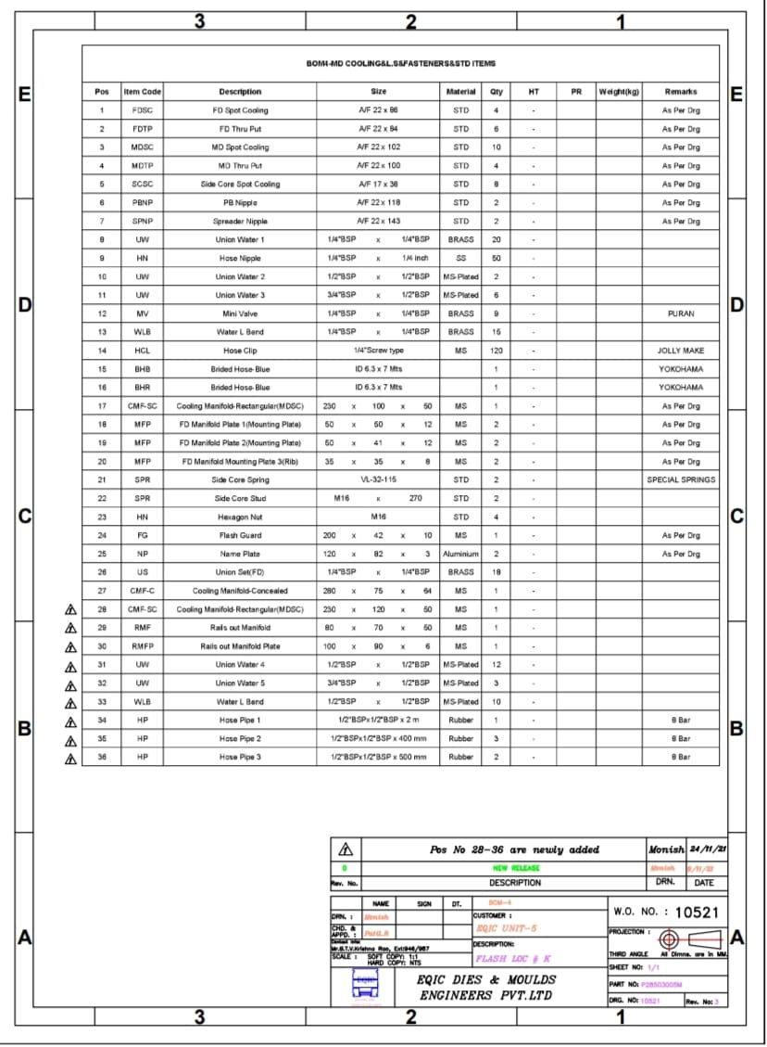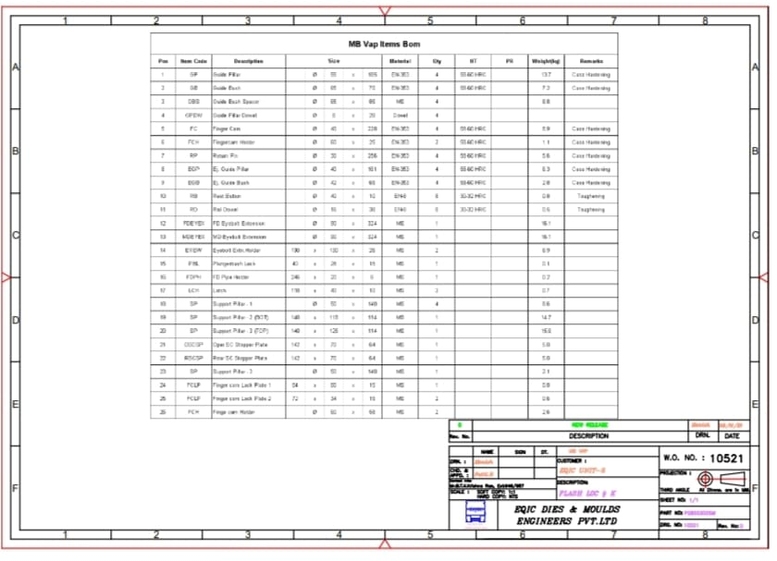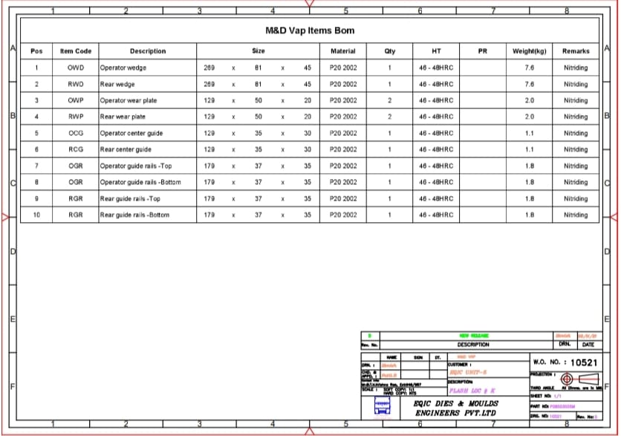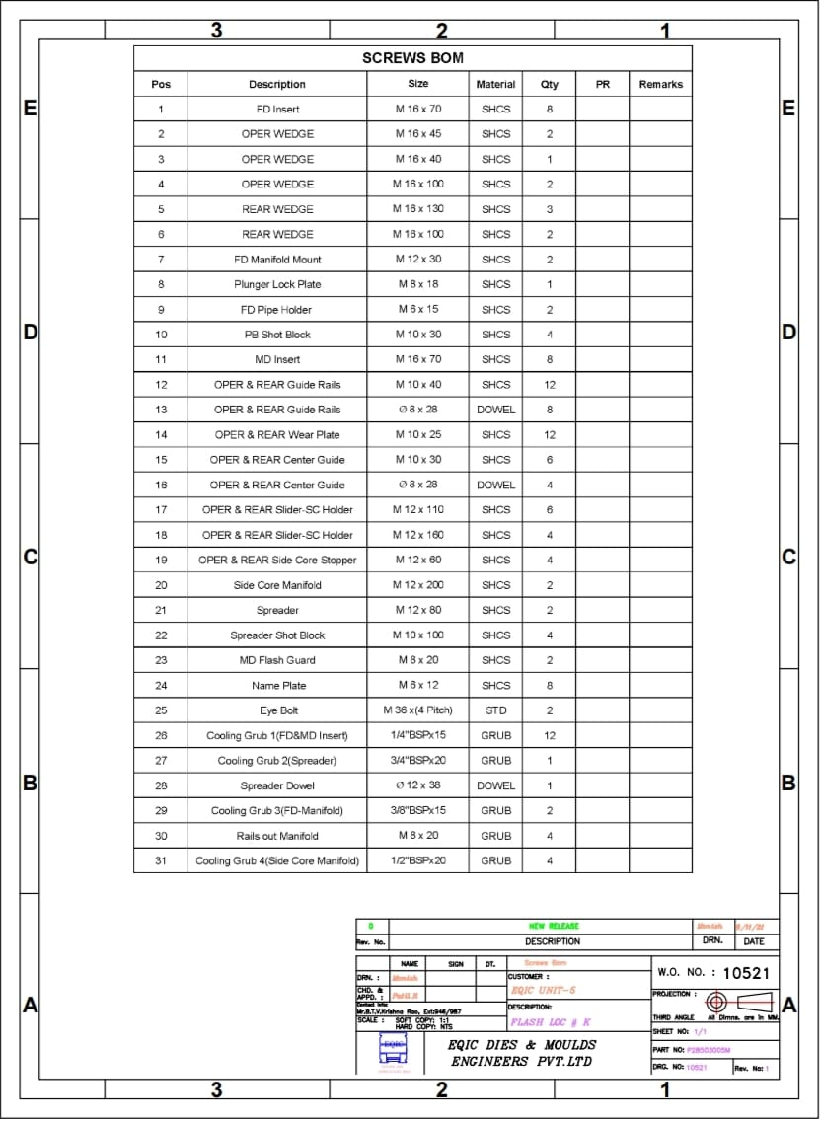
Purchase order:
